**New Mexico**

**Continuum Boards**

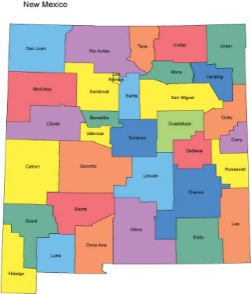

**Coordinator**

**Manual**

*Providing Healthy Opportunities for New Mexico Youth*

*August 2020*

*Updated*

# Table of Contents

Table of Contents 2

NM Juvenile Justice Legislation 5

**Section 1:**

1.1 State Legislation 5

1.1.1 NM Continuum Act: 5

1.1.1a. Rules and Regulations 6

1.1.2 Juvenile Community Corrections 6

1.1.3 Senate Bill 58 6

1.1.4 Other Legislation – Youth Mentoring 7

1.1.5 Resources 8

1.2 Federal Legislation 8

1.2.1 Juvenile Reform Act 9

1.2.2. SAG 10

1.2.3 Resources 10

1.2.3a. CJJ 10

1.2.3b. OJJDP 11

1.3 Juvenile Detention Alternatives Initiative (JDAI): 11

1.3.1 Reducing Racial and Ethnic Disparities 12

NM Coordinator Duties / Forms 13

**Section 2:**

2.1 Coordinator Duties List 13

2.2 Coordinator Activity Log 14

2.2.1 Coordinator Activity Log Sample #1 14

2.2.2 Coordinator Activity Log Sample #2 15

Board Development and Support 16

**Section 3:**

3.1 Board Development 16

3.2 Strategic Planning and Community Needs Assessments 16

3.3 Agenda 17

3.4 Meeting Minutes 19

3.5 Meeting Sign-In Sheet 21

3.6 Youth Engagement Manual 21

3.7 Local Youth Engagement Training 23

3.8 Sample Bylaws 23

3.9 Community Needs Assessment 24

3.10 Sample Board MOU 24

3.11 Other Resources 25

Program Development and Support 25

**Section 4:**

4.1 5 Priority Programs Document 25

4.2 Sample Program Referral(s) Form 26

4.3 Target Population 27

4.4 Existing Programs 27

Contract Management 28

**Section 5:**

5.1 Fiscal Agent Roles 28

5.2 Request to Subcontract 28

5.3 Financial Management 30

5.3.1 Best Practice: BAR Budget Adjustment Requirement 30

5.3.2 FY19 REVERSION EXPLANATION 30

5.4 Annual Report Requirements 32

5.5 Information on Background Checks 32

5.6 RFP / Grant Agreement Guidance 33

5.7 Match 33

5.8 Audit Information 34

FAQ’s 35

Glossary 36

**Disclaimer** 37

CYFD Special Programs Contact Information 37

Continuum Board Leader Contact Information 38

*Foreword:*

*In 2019 the New Mexico Continuum Coordinators developed the Continuum Coordinator manual to introduce new coordinators to the work. This manual does not take the place of legal advice from your county or the guidance documents or contractual documents from CYFD.  This manual is meant to help orient new coordinators to their work as quickly as possible. The manual was designed with many links which lead to updated information, the Continuum Coordinator’s website, and training.*

*- The 2019 New Mexico Continuum Coordinators*

# NM Juvenile Justice Legislation

**Section 1:**

Juvenile Justice continuum boards were created out of state statute and designed to meet the unique needs of the youth and the families in the communities in which they are located.

Below are the acts, initiatives, and reforms that guide the Continuum Boards across the involved counties in New Mexico.

## State Legislation

Since 2003, New Mexico State Legislators have had a strong commitment to embedding consistent quality improvement measures for the Juvenile Justice system into New Mexico Statute. The New Mexico Children’s Code embeds the 8 Core Principles of the Juvenile Detention Alternatives Initiative to guide the work of juvenile justice systems professionals. The Continuum Act and the Juvenile Community Corrections Act provide monies to support the implementation of the 8 Core principles of JDAI as well as the 4 Core Principles of the Federal Juvenile Reform Act.

### NM Continuum Act:

Section 9-2A-14.1- Juvenile continuum grant fund; created; purposed; administration; grant applications.

1. The “juvenile continuum grant fund” is created as a nonreverting fund in the state treasury. The fund shall be administered by children, youth and families department and shall consist of appropriations, gifts, grants, donations and bequests made to the fund.
2. Money in the juvenile continuum grant fund is subject to appropriation by the legislature to the children, youth and families department for awarding grants to juvenile justice continuums for the provision of cost-effective services and temporary, nonsecure alternatives to detention for juveniles arrested or referred to juvenile probation and parole or at a risk of such referral.
3. A local or tribal government may apply for a grant from the juvenile continuum grant fund for a juvenile justice continuum within its jurisdiction. The amount of the grant application shall not exceed sixty percent of the annual cost of the continuum. A local match of forty percent may consist of money, land, equipment or in-kind services.
4. The children, youth and families department shall adopt rules on qualifications for grants and specify the format, procedure and deadlines for grant applications. The juvenile justice advisory committee shall review all grant applications and submit those applications recommended for final approval to the secretary of children, youth and families.
5. Disbursements from the juvenile continuum grant fund shall be made upon vouchers issued and signed by the secretary of children, youth and families or the secretary’s designee upon warrants drawn by the secretary of finance and administration.
6. As used in this section, a “juvenile justice continuum” is a system of services and sanctions for juveniles arrested or referred to juvenile probation and parole or at risk of such referral and consists of a formal partnership among one or more of the units of local or tribal governments, the children’s court, the district attorney, the public defender, local law enforcement agencies, the public schools and other entities such as private nonprofit organizations, the business community and religious organizations. A juvenile justice continuum shall be established through a memorandum of understanding and a continuum board.

**Links**

[Link to Juvenile Continuum Grant Funds Program page on CYFD Website](https://cyfd.org/jjs-special-programs/grant-management-unit/juvenile-continuum-grant-funds)

#### 1.1.1a. Rules and Regulations

[Link to Rules and Regulations for the NM Continuum Act](https://cyfd.org/docs/continuum_statute.pdf)

### 1.1.2 Juvenile Community Corrections

The Juvenile Community Corrections (JCC) program provides services to assist adjudicated youth and youth on supervised release to successfully complete their probation or release requirements for successful reentry into the community.

Program referrals are made to JCC service providers from juvenile probation officers, district court judges, district attorneys, public defenders, private attorneys, juvenile correctional facilities or the CYFD supervised release panel.  The program utilizes a team approach which includes the client, family, JCC-contracted agency, local public schools staff, juvenile probation officers and other significant individuals in the client’s life. The program provides participants with program services based on the client’s individualized needs but focuses primarily on teaching life skills (job search support, social skills development, school support and tutoring, and other services offered within the community) so that the youth can learn how to appropriately and responsibly manage their affairs.

JCC served 966 youth through 16 contracted providers with services in 29 counties, supported by a budget of approximately $2.6 million in 2018. In 2019, JCC served 895 youth through 31 counties with 17 service providers.

**Links**

[Link to Full JCC Statute](https://law.justia.com/codes/new-mexico/2011/chapter33/article9A/)

[Link to CYFD Special Programs JCC Webpage](https://cyfd.org/jjs-special-programs/grant-management-unit/juvenile-community-corrections-jcc)

### 1.1.3 Senate Bill 58

Evidence and Research Based Funding Request

Senate Bill 58, signed into law during the 2019 legislative session, amended the Accountability in Government Act to require certain state agencies to identify and prioritize evidence-based, research-based, and promising sub-programs within their performance-based budget request. The purpose of Senate Bill 58 is to help agency leadership and our elected officials better understand the effectiveness of different government programs within various policy areas in order to make the best use of limited taxpayer dollars.

Definitions

**“Evidence-based”** means that a program or practice: (1) incorporates methods demonstrated to be effective for the intended population through scientifically based research, including statistically controlled evaluations or randomized trials; (2) can be implemented with a set of procedures to allow successful replication in New Mexico; and (3) when possible, has been determined to be cost beneficial.

**“Research-based”** means that a program or practice has some research demonstrating effectiveness, but does not yet meet the standard of evidence-based.

**“Promising”** means that a program or practice, based on statistical analyses or preliminary research, presents potential for becoming research-based or evidence-based.

**Links**

[Link our NM Juvenile Justice Continuum Site Coordinators Website](https://continuumdaily.wixsite.com/nmcontinuums)

[Link to Full Senate Bill 58](https://www.nmlegis.gov/Legislation/Legislation?Chamber=S&LegType=B&LegNo=58&year=19)

[Link to Pew-MacArthur Results First Clearinghouse Database](https://www.pewtrusts.org/en/projects/results-first-initiative)

[A Common Language for Evidence Based Programming page on the Pew Website](https://www.pewtrusts.org/en/research-and-analysis/fact-sheets/2017/11/a-common-language-for-evidence-based-programming)

[Defining Levels of Evidence page from PEW Website](https://www.pewtrusts.org/en/research-and-analysis/fact-sheets/2015/11/defining-levels-of-evidence)

[Article Containing Several links to Various Reports on Evidence Based Policy Making from PEW Website](https://www.pewtrusts.org/en/research-and-analysis/reports/2018/12/10/how-counties-can-use-evidence-based-policymaking-to-achieve-better-outcomes)

### 1.1.4 Other – Youth Mentoring

New Mexico’s Children, Youth and Families Department (CYFD) is committed to supporting a network of quality youth mentoring providers and effective approaches that provide a consistent, positive influence in the lives of youth people who would benefit from mentoring support, connecting the young person to personal growth and development, and social and economic opportunities.

Contact Information

|  |  |
| --- | --- |
| **One-on-One Youth Mentoring Providers** | **Counties, Pueblos/Nations Served** |
| **Big Brothers Big Sisters Mountain Region**  David Sherman, CEO - [David.Sherman@bbbsmountainregion.org](mailto:David.Sherman@bbbsmountainregion.org)  Program Contact, Gina Trujillo  [Gina.Trujillo@bbbsmountainregion.org](mailto:Gina.Trujillo@bbbsmountainregion.org)  CYFD/JJS Contact: Cindy Varela | Rio Arriba, Taos, Colfax, McKinley, Santa Fe, Los Alamos, San Miguel, Mora, Grant, Dona Ana, Luna |
| **Big Brothers Big Sisters Central NM**  Angela Reed Padilla, CEO –  [Angela.ReedPadilla@bbbs-cnm.org](mailto:Angela.ReedPadilla@bbbs-cnm.org)  Program Contact, Sharon Tenorio COO – [Sharon.Tenorio@bbbs-cnm.org](mailto:Sharon.Tenorio@bbbs-cnm.org)  CYFD/JJS Contact: Louis Pacias | San Juan, Sandoval, Bernalillo, Torrance, Valencia, Cibola, Socorro, Otero |
| **Big Brothers Big Sisters Southeastern NM**  Bill Wolfe, CEO - [bwolf@bbbssenm.org](mailto:bwolf@bbbssenm.org)  Program Contact, Amanda Ware - [aware@bbbssenm.org](mailto:aware@bbbssenm.org)  CYFD/JJS Contact: Consuelo Garcia | Curry, Roosevelt, Chaves, Eddy |
| **Youth Development, Inc.**  Concho Cordova, Vice President - [ccordova@ydinm.org](mailto:ccordova@ydinm.org)  Program Contact: Judy Pacheco - [jpacheco@ydinm.org](mailto:jpacheco@ydinm.org)  CYFD/JJS Contact: Louis Pacias | Sandoval, Bernalillo, Valencia, Torrance |

|  |  |
| --- | --- |
| **Group Youth Mentoring Providers** | **Counties, Pueblos/Nations Served** |
| **National Indian Youth Leadership Development Program**  McClellan Hall, CEO – [machall@niylp.org](mailto:machall@niylp.org)  Program Contact: Sheri Pfeiffer-Tsinajinnie [spfeiffertsinajinnie@niylp.org](mailto:spfeiffertsinajinnie@niylp.org)  CYFD JJS Contact: Louis Pacias | McKinley County; Navajo Nation |
| **New Mexico Alliance of Boys & Girls Clubs**  Program Contact: Debbie Davis - [ddavis@bgcalliances.net](mailto:ddavis@bgcalliances.net)  CYFD JJS Contact: Consuelo Garcia | San Juan, Rio Arriba, McKinley, Sandoval, Santa Fe, Bernalillo, Lincoln, Chaves, Eddy, Otero, Dona Ana; Ohkay Owingeh, Mescalero Apache |
| **Appletree**  Program Contact: Sharon Finarelli - [sharon.finarelli@appletreeeducation.org](mailto:sharon.finarelli@appletreeeducation.org)  CYFD JJS Contact: Cindy Varela | Sierra |
| **Capacity Builders**  President, Board of Director: Debbie Oftedal – [d.oftedal@capacitybuilders.info](mailto:d.oftedal@capacitybuilders.info)  CYFD JJS Contact: Cindy Varela | San Juan County; Navajo Nation |
| **Youth Development, Inc.**  Concho Cordova, Vice President - [ccordova@ydinm.org](mailto:ccordova@ydinm.org)  Program Contact: Judy Pacheco - [jpacheco@ydinm.org](mailto:jpacheco@ydinm.org)  CYFD/JJS Contact: Louis Pacias | Bernalillo County |

**Links**

[Link to Youth Mentoring Programs page on CYFD website](https://cyfd.org/jjs-special-programs/grant-management-unit/one-on-one-and-group-youth-mentoring-programs)

### 1.1.5 Resources

[NM Legislature Bill Finder Home Page](https://www.nmlegis.gov/Legislation/Legislation?Chamber=S&LegType=B&LegNo=58&year=19)

[Results First Clearinghouse Database](https://www.pewtrusts.org/en/research-and-analysis/issue-briefs/2014/09/results-first-clearinghouse-database)

[OJJDP Model Programs Guide](https://www.ojjdp.gov/mpg/)

[Crime Solutions Website](https://www.crimesolutions.gov/)

## Federal Legislation

The Juvenile Justice and Delinquency Prevention Act of 1974, Public Law 93–415, as amended, established the Office of Juvenile Justice and Delinquency Prevention (OJJDP) to support local and state efforts to prevent delinquency and improve the juvenile justice system.

OJJDP provides national leadership, coordination, and resources to prevent and respond to juvenile delinquency and victimization. OJJDP supports the efforts of states, tribes, and communities to develop and implement effective and equitable juvenile justice systems that enhance public safety, ensure youth are held appropriately accountable to both crime victims and communities, and empower youth to live productive, law-abiding lives.

### 1.2.1 Juvenile Reform Act

CYFD’s Special Programs Unit monitors law enforcement to ensure statutory compliance to the federal Office of Juvenile Justice and Delinquency Prevention (OJJDP) core requirements of deinstitutionalization of status offenders, addressing racial and ethnic disparities,  sight and sound separation of adults and juveniles, and removal of juveniles from adult jails and lockups.

***Deinstitutionalization of Status Offenders*** (DSO): Status offenses are offenses that are only crimes if committed by children, such as skipping school, running away, breaking curfew, and possession or use of alcohol.  Under the JJDPA, status offenders may not be held in secure detention or confinement. Instead, these children are to receive community-based services, such as day treatment or residential home treatment, counseling, mentoring, alternative education and job development support.

JJRA of 2018 Changes to DSO: Youth who are found in violation of a valid court order may be held in detention, for no longer than seven days, if the court finds that such detention is necessary and enters an order containing the following: 1) identifies the valid court order that has been violated; 2) specifies the factual basis for determining that there is reasonable cause to believe that the status offender has violated such order; 3) includes findings of fact to support a determination that there is no appropriate less restrictive alternative available to placing the status offender in such a facility, with due consideration to the best interest of the juvenile; 4) specifies the length of time, not to exceed seven days, that the status offender may remain in a secure detention facility or correctional facility, and includes a plan for the status offender's release from such facility. Such an order may not be renewed.

***Racial and Ethnic Disparities*** (RED): Formerly under the Disproportionate Minority Contact requirement, states were required to assess and address the disproportionate contact of youth of color at key decision points in the juvenile justice system.  The JJRA of 2018 requires States to focus on Racial and Ethnic Disparities (RED). The Act requires that states collect and analyze data on racial and ethnic disparities, and requires states to determine which points of system contact create racial and ethnic disparities, and establish a plan to address these system points.

[Link to Reducing Racial and Ethnic Disparity page on CYFD Website.](https://cyfd.org/jjs-special-programs/reducing-racial-and-ethnic-disparity)

***Jail Removal***: Juveniles may not be detained in adult jails except for limited ("de minimis") periods before release or transporting them to an appropriate juvenile placement (6 hours), in rural areas (24 hours plus weekends and holidays), or when weather and travel conditions prevent authorities from transporting them. Research indicates that children housed in adult jails are eight times as likely to commit suicide, five times as likely to be sexually assaulted, twice as likely to be assaulted by staff, and 50 percent more likely to be attacked with a weapon, than children in juvenile facilities.

***Sight and Sound Separation***: When children are held in an adult jail under the exceptions listed above, they may not have any sight or sound contact with adult inmates. Thus, children cannot be housed with adult inmates or next to adult cells, share dining halls, recreation areas, or any other common spaces with adult inmates, or be placed in any circumstances in which they could have any visual or verbal contact with adult inmates.  The JJRA of 2018 requires that not later than 3 years after the date of enactment, States are required to ensure sight and sound separation and jail removal for youth awaiting trial as adults. This protection previously applied only to youth being held on juvenile court charges.  An exception continues to exist for cases where a court finds, after a hearing and in writing, that it is in the interest of justice.

**Links**

[Link to the Summary of the 2018 Reforms of the JJDPA on the Continuum Coordinators site.](https://b58a0a99-a9ad-451b-8685-43a64b0dde0d.filesusr.com/ugd/5b2008_2ba0fa57465a4f5db5ee03785930c57c.pdf)

[Link to page on Compliance Monitoring and the Juvenile Reform Act on the CYFD website.](https://cyfd.org/jjs-special-programs/state-and-federal-compliance/compliance-monitoring)

[Link to JJDPA Reauthorization and changes to Juvenile Reform Act](https://b58a0a99-a9ad-451b-8685-43a64b0dde0d.filesusr.com/ugd/5b2008_4685b9ca131f4728b06bf2be7918c87e.pdf)

#### 1.2.2. SAG

SAG stands for “State Advisory Group”. SAGs are established in federal law (in the JJDPA). In each state or U.S. territory, a SAG may be known by an alternative title, such as a “commission” or “council.” In New Mexico, our SAG is titled “Juvenile Justice Advisory committee” (JJAC).

JJAC is appointed by the Governor and is advisory to CYFD (Children Youth and Families Department), the Governor and the Legislature. The JJAC advocates for the prevention of delinquency, alternatives to secure detention, improvement of the juvenile justice system and the development of a continuum of graduated sanctions for juveniles in local communities. The JJAC allocates federal and state grant funds to communities in New Mexico for these purposes. Currently there are twenty regional Juvenile Justice Continuum Boards have been developed in communities across the state to address the goals of the state advisory group, JJAC.

[Link to Juvenile Justice Advisory Committee page including more information on CYFD website.](https://cyfd.org/jjs-special-programs/juvenile-justice-advisory-committee-jjac)

**Links**

[Link to Office of Juvenile Justice and Delinquency Prevention Homepage](https://ojjdp.ojp.gov/)

### 1.2.3 Resources

There are several national go-to resource sites to aid continuum coordinators in the understanding of their work. These sites contain information on grant funding opportunities, on training, and on national promising best and evidence based practices for juvenile justice.

#### 1.2.3a. CJJ

Coalition for Juvenile Justice

As our members’ national presence, we educate and inform Members of Congress and the Administration on state-identified needs and concerns in the arena of juvenile justice. Each year, CJJ publishes and disseminates recommendations to the Administration and to Congress. We also create tools and resources to support our members’ work in the states and territories. CJJ hosts an annual Hill Day in conjunction with our national conference in Washington, DC.

CJJ is a member of and works closely in collaboration with the [National Juvenile Justice and Delinquency Prevention Coalition (NJJDPC)](http://juvjustice.org/reform-initiatives/national-juvenile-justice-and-delinquency-prevention-coalition). The NJJDPC is a collaborative array of youth and family serving, social justice, law enforcement, corrections, and faith-based organizations. The Coalition works to ensure healthy families, build strong communities, and improve public safety by promoting fair and effective policies, practices, and programs for youth involved or at risk of becoming involved in the juvenile and criminal justice systems. CJJ staff serves on the NJJDPC steering committee and co-chairs the coalition's [Act 4 JJ](http://act4jj.org/) working group.

[Link to CJJ Home Page](http://juvjustice.org/)

#### 1.2.3b. OJJDP

Office of Juvenile Justice and Delinquency Prevention

Originally enacted in 1974, the Juvenile Justice and Delinquency Prevention Act (JJDPA) is a federal law that provides delinquency prevention grants to states and localities to improve systems and practices, and to establish basic safeguards known as core requirements for states and localities to follow regarding the care and custody of youth who come into contact with the justice system.

In addition, the JJDPA establishes a structure for citizen input and oversight of state implementation of the law’s mandates and programs; through the work of a State Advisory Group (SAG) appointed by the governor or chief executive in each jurisdiction.

The JJDPA requires youth to serve as equal members of their SAGs along with adults. The JJDPA also requires involvement of youth in all SAGs, to include youth who are, or have been involved in the juvenile justice system.

[Link to OJJDP Home Page](https://ojjdp.ojp.gov/)

**Links**

[Link to CYFD page on JJS Special Programs and related links](https://cyfd.org/jjs-special-programs)

## Juvenile Detention Alternatives Initiative (JDAI):

New Mexico's System Improvement approach is based on Annie E. Casey Foundation’s Juvenile Detention Alternatives Initiative (JDAI). It is designed to enable jurisdictions to safely reduce reliance on secure confinement through continuous juvenile justice system improvement.

JDAI is intended to: 1) Eliminate inappropriate or unnecessary use of secure detention (2) Minimize failures to appear and incidence of delinquent behavior; (3) Redirect public finances to successful reform strategies; (4) Improve conditions in secure detention facilities; and (5) Reduce racial and ethnic disparities.

1. Collaboration: All juvenile justice systems must work together in order to successfully reform
2. Data Driven Decision Making: JDAI is a results based initiative that uses objective data analysis to drive reform
3. Eliminating Disparities: Using specific strategies to eliminate bias
4. Objective Admissions Criteria: Utilizing screening instruments to distinguish youth who are likely to flee or be arrested again and those who are not
5. Alternatives to Detention: Provide supervision, structure and accountability
6. Case Processing Reforms: Modifying juvenile justice procedures to decrease delays in procedures that are unnecessarily lengthy.
7. Special Detention Cases: Examining cases that contribute to large percentages of inappropriate or unnecessary stays in detention
8. Conditions of Confinement: Regular facility assessment checks to ensure that confinement centers are adequately evolving to maintain safe and humane conditions for the residents.

[Link to JDAI Website](https://www.aecf.org/work/juvenile-justice/jdai/)

Get Connected to the most current information on Juvenile Justice Reform in the country. Just click to connect.

[Link to CYFD website on New Mexico’s use of JDAI system improvement.](https://cyfd.org/jjs-special-programs/system-improvement-initiative)

[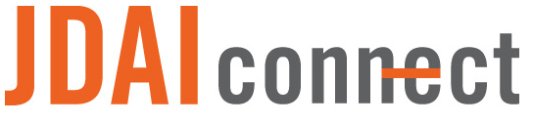](https://www.aecf.org/work/juvenile-justice/jdai/jdaiconnect/)

### Reducing Racial and Ethnic Disparities

[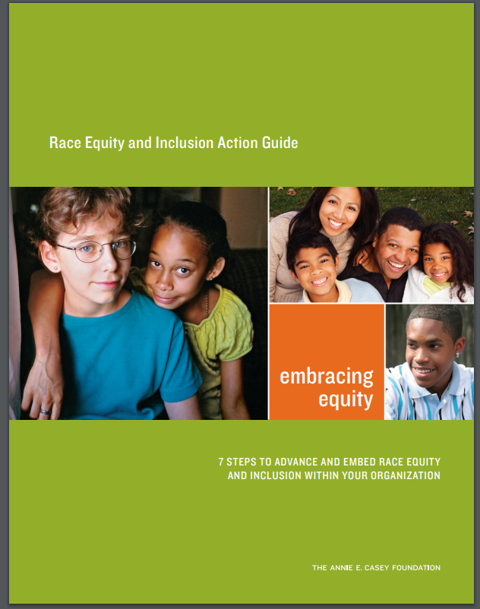](http://www.bernco.gov/uploads/files/Race%20Equity%20and%20Inclusion%20Action%20Guide%20Annie%20E%20Casey%20Foundation.pdf)

[Link to RRED Manual](https://www.bernco.gov/uploads/files/Race%20Equity%20and%20Inclusion%20Action%20Guide%20Annie%20E%20Casey%20Foundation.pdf)

[Link to RRED Bernalillo County RRED Committee Resource page](http://www.bernco.gov/health-and-public-safety/rred-committee-resources.aspx)

# NM Coordinator Duties / Forms

**Section 2:**

There is a list of duties Continuum Coordinators and the CYFD Special Programs Unit have compiled, in order to best aid coordinators in successfully fulfilling their role. These duties and the Coordinators role description are described in the section below. Additionally, Continuum Coordinators are required to fill out, and submit to CYFD annually, “Activity Logs” which define Juvenile Justice Advisory Committee activities and all related expenses.



## Coordinator Duties List

The following list was developed through the collaborative effort of the continuum coordinators and the CYFD Special Programs Unit. These are the activities from the Grant Guidance and the Scope of Work within the contract for FY20.

**Coordinator:** The Juvenile Justice Continuum Coordinator:

1. Organizes, coordinates and provides staff support for the Community Advisory Board (CAB); this will include board development activities in conjunction with the CAB chair;
2. Informs the Agency's Grant Manager of the date of each meeting and submits a copy of the written minutes of each meeting within thirty (30) days of the meeting;
3. Coordinate/oversee the programmatic delivery of subcontract requirements of local Continuum service providers;
4. Submits to the Agency's Grant Manager monthly requests for reimbursement.  Such requests will be submitted on Agency Program Invoice and Expenditure Report forms, signed and sated by an authorized agent of the Contractor, to ensure that requests for reimbursement are submitted by the due date of the fifteenth (15) day of the following month, unless otherwise approved by the Agency's Grant Manager, in advance;
5. Provides data reports as required by the federal government, corresponding to the activities described in this Scope of Work. The Agency's Grant Manager will provide the data report format. Programmatic data reports will be submitted monthly to the Agency and must accompany the monthly invoice. Failure to submit such programmatic data and financial reports may result in notice to the Contractor of non-availability of funds and/or the denial of payment by the Agency;
6. Provides the Agency standardized progress reports monthly;
7. Submits to the Agency a written "Final Report" no later than 15 days after the termination of this Agreement and such other reports deemed necessary by the Agency. The Final Report shall contain at a minimum, but not be restricted to:
   1. a year plan for sustainability of programs/services;
   2. accomplishments/milestones achieved during this Agreement period;
   3. statements regarding achievements, obstacles and progress made regarding the performance measures and related outcomes; and
   4. continuing development and improvement of the Comprehensive Strategic Plan for a continuum of detention alternative program and services.
8. Attend meetings as required by the Agency
9. Attend job-relevant training for professional development and Continuum networking
10. Promote programs with schools, local government, agencies, and youth and parents through community presentations, events and meetings.

## Coordinator Activity Log: Payroll/ Hours Worked

 Payroll reimbursement requests must be supported by the following:

* 1. Timecards or activity logs shall clearly state the dates of service and signed/approved by a supervisor; and
  2. Proof of payment. Payment may be supported by a copy of the cancelled check, direct deposit slip, or a General Ledger (G/L) Account report.

Timecards and activity logs supply detail. They are to be cross-checked for overbilling, duplication of services and/or billing, the sum of hours/payment calculating correctly, and unallowable activities/services/hours.

Please remember that the Contractor and its subcontractors shall not solicit for donations for a program, nor lobby for political office/elected official while being paid with these funds.

[Links to Continuum Coordinator Website Coordinator Duties and Forms Page](https://continuumdaily.wixsite.com/nmcontinuums/coordinator-duties-and-forms)

### 2.2.1 Coordinator Activity Log Sample #1

|  |  |  |  |  |  |  |  |  |  |  |  |
| --- | --- | --- | --- | --- | --- | --- | --- | --- | --- | --- | --- |
| **[Continuum Name]** | | | | | | | | **ACTIVITY LOG** | | | |
|  |  |  |  | |  |  | | |  |  |  |
| Coordinator Name: | |  | |  | | | |  | | |  |
| Phone: |  | | | |  | Address: | | |  | | |
| Email: |  | | | | |  | | |  | | |
|  |  |  |  | |  |  | | |  |  |  |
| Invoice: |  | | Period: | |  | | Hrly Rate: | $ - | | | |
|  |  |  |  | |  |  | | | (Up to $22/Hr) |  |  |
|  |  |  |  | |  |  | | |  |  |  |
| Date | JJAC Specific Activities | | | JJAC Hrs | | | | Non-JJAC Hrs *(Optional)* | | | JJAC Amount |
| 1 |  | | |  | | | |  | | | $ - |
| 2 |  | | |  | | | |  | | | $ - |
| 3 |  | | |  | | | |  | | | $ - |
| 4 |  | | |  | | | |  | | | $ - |
| 5 |  | | |  | | | |  | | | $ - |
| 6 |  | | |  | | | |  | | | $ - |
| 7 |  | | |  | | | |  | | | $ - |
| Notes: | | | | | | | | | | | |
|
|
|
| Supervisor's Approval: | | |  | | | | | | | | |

### 2.2.2 Coordinator Activity Log Sample #2

**Continuum Name:­**

Coordinator Name:

Address:

City, State & Zip:

Phone:

Email:

Invoice # **_______** Invoice Period: **­­­­________________** Hourly Rate **$­­­­________**

|  |  |  |  |  |
| --- | --- | --- | --- | --- |
| Service Area | Description of Services *(e.g., 7/6: 4 hrs, CAB staff support)* | | Hours | Amount |
| Organize, coordinate and provide staff support for the Community Advisory Board (CAB); including board development activities in conjunction with the CAB chair |  | |  | $ |
| Inform CYFD's Grant Manager of the date of each meeting and submit a copy of the written minutes of each meeting |  | |  |  |
| Submit to the Grant Manager monthly requests for reimbursement |  | |  | $ |
| Provide data reports as required by the federal government, corresponding to the activities described in the Scope of Work |  | |  | $ |
| Provide standardized progress reports monthly |  | |  | $ |
| Submit a written "Final Report" and such other reports deemed necessary by the Agency |  | |  |  |
| Attend meetings as required by the Agency |  | |  | $ |
| Interaction & coordination with continuum program providers |  | |  | $ |
| Supervisor  Signature: | | Totals Hours Billed to JJAC Grant | $ | |

$ charged to JJAC Grant = # of hours @ up to $22

# Board Development and Support

**Section 3:**

Developing a Juvenile Justice Continuum Boards is required when a county or city receives funding from the New Mexico Juvenile Justice Continuum Fund.



## Board Development

If a city or county applies for continuum funding, they are required by the New Mexico Juvenile Continuum Act to develop an Advisory Board to create and guide a continuum of services. Currently there are twenty Juvenile Justice Continuum Boards in New Mexico. Under the Juvenile Continuum Act, all Continuum Boards are required to have officials and public agencies, and tribal equivalents, whose partnership in the juvenile justice continuum is statutorily required.

Required Stakeholders

· a unit of local or Tribal Government

· the Children’s Court

· the District Attorney

· the Public Defender

· a local (municipal, county, tribal) Law Enforcement agency

· the Public School district

Besides the required partners, many boards encourage community involvement by inviting representatives of public agencies (advocacy organizations), private nonprofit organizations, families, and youth membership to sit on the Board.

[Link to Board Member Application Sample](https://b58a0a99-a9ad-451b-8685-43a64b0dde0d.filesusr.com/ugd/5b2008_8b2194bbf46a4b52a8b93ae20670fce8.docx?dn=Membership%20Application.docx)

[Link to Sample Board Member Invitation](https://b58a0a99-a9ad-451b-8685-43a64b0dde0d.filesusr.com/ugd/5b2008_e0b848739adc4750beaffe1533de1338.docx?dn=Sample%20Letter%20of%20Invite%20to%20Board.docx)

## Strategic Planning and Community Needs Assessments

CYFD has provided some training to guide coordinators on Strategic Planning Processes.

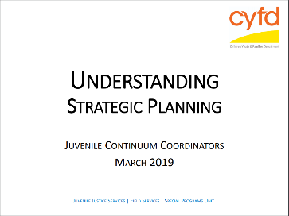[Link to Strategic Planning Power Point on the Continuum Coordinators Website.](https://b58a0a99-a9ad-451b-8685-43a64b0dde0d.filesusr.com/ugd/5b2008_3b8176ef74de4beab3628ac1f01a6eeb.pdf)

[Link to additional resources on Strategic Planning from BoardSource.](https://boardsource.org/fundamental-topics-of-nonprofit-board-service/strategic-planning/)

[Link to Document on Board Role in Strategic Thinking and Planning](http://virginiaservice.virginia.gov/wp-content/uploads/2017/01/The-Board-Role-in-Strategic-Thinking-and-Planning.pdf)

## Agenda

|  |  |  |  |  |  |  |  |  |  |  |
| --- | --- | --- | --- | --- | --- | --- | --- | --- | --- | --- |
| **Juvenile Justice Continuum Board Meeting**  ***Come with meeting results in mind and leave with action commitments in hand***  **Meeting Title:** | | | | | | | | | | |
| **Date & Time: Location:** | | | |  | | | | | | |
|  | | | | | | |
| **Meeting Purpose** | | | | | | |
|  | | **Action commitment**  **follow-up** | | **Accomplished** | **Some progress** | **Not addressed** | | | **Next steps** | |
|  | |  | |  |  |  | | |  | |
|  | |  | |  |  |  | | |  | |
|  | | | | | | | | | | |
|  | | | **Time** | **Task/Result** | | | **Notes: Insights, Decisions, Next Steps** | | | |
|  | | | 12:00-12:15 | **Task: Welcome and Introductions**  **Result:** | | |  | | | |
|  | | | Allotted time frame for task | **Task:**  **Result:** | | |  | | | |
|  | | |  | **Task:**  **Result:** | | |  | | | |
|  | | |  | **Task:**  **Result:** | | |  | | | |
|  | | |  | **Adjourn** | | |  | | | |
| **Leave with Action Commitments!** | | | | | | | | | | |
|  | **Who needs to take action?** | | | **Action Commitment** | | | | **Date completed** | | **Why is this action a priority?** |
|  |  | | |  | | | |  | |  |

[Link to Agenda Template Example](https://b58a0a99-a9ad-451b-8685-43a64b0dde0d.filesusr.com/ugd/5b2008_1b6966d7b6a84b00aa652c7990affd25.docx?dn=Meeting%20Minutes%20Template.docx)

Agenda Sample

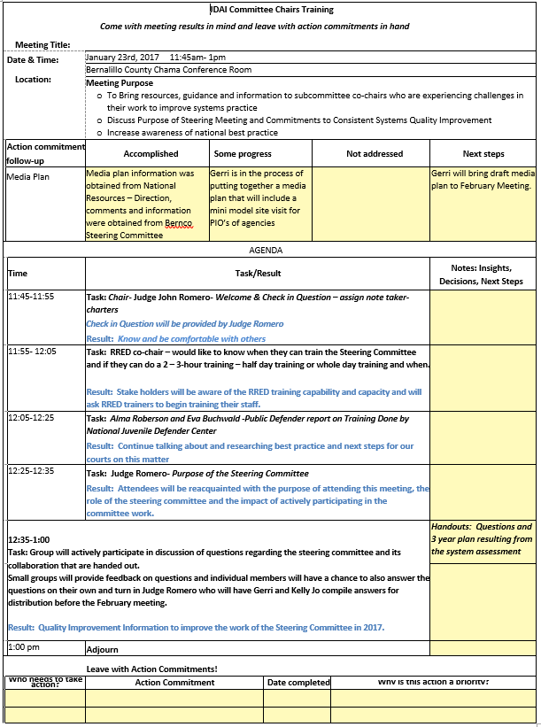



## Meeting Minutes

The Coordinator is required to submit the dates of each meeting as well as the meeting minutes to the Grant Manager within 30 days of the meeting.

[Link to Meeting Minutes Template](https://b58a0a99-a9ad-451b-8685-43a64b0dde0d.filesusr.com/ugd/5b2008_1b6966d7b6a84b00aa652c7990affd25.docx?dn=Meeting%20Minutes%20Template.docx)

[Sample Luna County Meeting Minutes](https://b58a0a99-a9ad-451b-8685-43a64b0dde0d.filesusr.com/ugd/5b2008_7bd7731c481b4701861b910d93b37fa4.docx?dn=Meeting%20Minutes%203.26.19.docx)

[Sample NM Continuum Board Meeting Minutes](https://b58a0a99-a9ad-451b-8685-43a64b0dde0d.filesusr.com/ugd/faf15c_c047e128c62741bf847fb1dc22106b73.docx?dn=Continuum%20Coordinator%20Meeting%20Minutes%205-)

|  |  |  |  |  |  |  |  |  |
| --- | --- | --- | --- | --- | --- | --- | --- | --- |
| **Meeting Title** | | | **:** |  | | | | |
| **Date** | | | **:** |  | | | | |
| **Time** | | | **:** |  | | | | |
| **Place** | | | **:** |  | | | | |
| **Chair Person** | | | **:** |  | | | | |
| **In Attendance** | | | **:** |  | | | | |
| **Absent** | | | **:** |  | | | | |
| **Minutes Submitted By** | | | **:** |  | | | | |
| **Minutes Submitted On** | | | **:** |  | | | | |
| **Next Meeting** | | | **:** |  | | | | |
| **#** | **Discussion** | | | | | | | |
|  |  | | | | | | | |
|  | **Approval of minutes from last meeting**: | | | | | | | |
|  | **Type of Meeting**: | | | | | | | |
|  | **Financials:**  **FY ’19 Budget JJCS Program**  The new and current unallocated after school program funding line item is now  **CYFD Continuum Programs:** **FY '19 Budget JJCS Program:**  **Gender Specific**:  **SFP**: | | | | | | | |
|  | **Presentation**: | | | | | | | |
|  | **Committee report back:**  **JPO Data**: | | | | | | | |
|  | **Program Reports:**  **Reading/Math Intervention**:  **Surveillance**: | | | | | | | |
|  | **Board Area of Interest:** | | | | | | | |
| **9.** | **Funding Requests: Deming First Assembly of God (Strengthening Families Program) – Desa Malina** | | | | | | | |
| **10.** | **Announcements:** | | | | | | | |
| **11.** | **Adjourn:** | | | | | | | |
| **#** | **Action Items:** | | | | | | | |
| **#** | **Action Item** | | | | **Owner** | **Status** | **Due Date** | **Comments** |
|  |  | | | |  |  |  |  |
|  |  | | | |  |  |  |  |
| **#** | **Carry-Over Items for Next Meeting:** | | | | | | | |
| **#** | **Description** | | | | | | | |
|  |  | | | | | | | |
| Notes: | |  | | | | | | |

## Meeting Sign-In Sheet

All boards are required to have a record of attendees and their signatures in order to ensure that quorum has been met for meetings that require voting, as well as to establish what objections are being achieved with attending members.

|  |  |  |  |
| --- | --- | --- | --- |
| Meeting Title: |  | Meeting Date: |  |
| Facilitator: |  | Meeting Time: |  |

| Voting Member Name | Email | Signature |
| --- | --- | --- |
| 1. Print Name Here |  |  |
| 1. Print Name Here |  |  |
| 1. Print Name Here |  |  |
| 1. Print Name Here |  |  |
| 1. Print Name Here |  |  |

| Print Name | Agency/ Community/ Other | Email / Phone # |
| --- | --- | --- |
| 1. |  |  |
| 2. |  |  |
| 3. |  |  |
| 4. |  |  |
| 5. |  |  |
| 6. |  |  |
| 7. |  |  |
| 8. |  |  |
| 9. |  |  |
| 10. |  |  |

[Link to Meeting Sign in Sheet Template](https://b58a0a99-a9ad-451b-8685-43a64b0dde0d.filesusr.com/ugd/5b2008_79b1c2163cc54205a9e5b5ecdff45e7a.docx?dn=Meeting%20Sign%20In%20Sheet.docx)

## Youth Engagement Manual

The Coalition for Juvenile Justice places a high priority on youth involvement in juvenile justice reform.  Youth members offer a unique perspective. Often, youth leaders best understand what policies, programs and changes will be most effective. The youth voice is vital to CJJ’s mission and students are an especially integral part of CJJ’s coalition.  We have several events, projects, resources, and opportunities that aim to engage youth.

[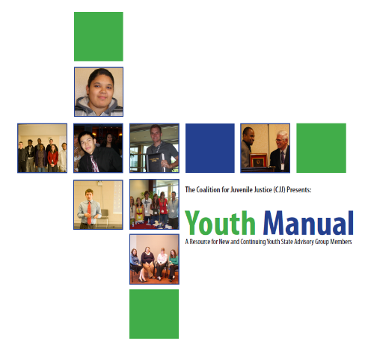](http://www.juvjustice.org/sites/default/files/resource-files/resource_391_0.pdf)

[Youth Manual from CJJ Website](http://www.juvjustice.org/sites/default/files/resource-files/resource_391_0.pdf)

[Youth Engagement Page on CJJ Website](https://www.juvjustice.org/our-work/youth-engagement)

**Youth Manual Outline** by the Coalition for Juvenile Justice

1. The Juvenile Justice and Delinquency Prevention Act (JJDPA)
2. The State Advisory Group (SAG)
3. How to be an Effective SAG Member
4. The JJDPA Core Requirements:
5. Core Requirement: Deinstitutionalization of Status Offenders
6. Core Requirement: Sight and Sound Separation
7. Core Requirement: Jail Removal
8. Core Requirement: Disproportionate Minority Contact (DMC)
9. Become the Expert – Educating your Legislature
10. State Three-Year JJDPA Plan
11. Coalition for Juvenile Justice (CJJ)
    1. CJJ National Youth Committee
    2. Annual CJJ Spirit of Youth Award
    3. Other CJJ Opportunities

## Local Youth Engagement Training

Albuquerque NM CAN Youth Engagement Training

“We work closely with young people and our community to lead change in the child welfare system. All children and youth impacted by systems in New Mexico benefit from our ongoing advocacy efforts.”

* NM CAN

NMCAN partners with young people to build community, promote equity, and lead change. Since 1990, NMCAN has been leveraging community partnerships and volunteerism to improve children and youth’s experiences in foster care. Today, we have grown to authentically engage young people impacted by the foster care and/or juvenile justice systems to improve their transition to adulthood. Together, we work to:

· Reduce systemic barriers that negatively impact their lives

· Help them learn how to build positive community networks and strengthen their sense of belonging

· Access tools to achieve goals related to education, employment, health, housing, and personal finance

We are steadfastly dedicated to young people as partners and understand the complexities of these systems. NMCAN is a leader within the child welfare community, driving positive and equitable change in New Mexico.

NM CANS Offers various youth Training to include the following:

· Back On Track Program

· Learn about Money- Opportunity Passport

· Leadership and Policy Work

· Transition Age Youth Project ECHO

[NM CAN Website](https://nmcan.org/)

## Sample Bylaws

All boards are required to create their own bylaws in order to maintain consistency. Below are some samples of bylaws created by different boards within NM.

[Link to Bernalillo County Juvenile Justice Continuum Board Bylaws on Continuum Coordinators website](https://continuumdaily.wixsite.com/nmcontinuums/board-development-and-support)

[JJAC Bylaws Link](https://cyfd.org/docs/JJAC_Bylaws_Final_for_website.pdf)

## Community Needs Assessment

A community needs assessment identifies the strengths and resources available in the community to meet the needs of children, youth, and families. The assessment focuses on the capabilities of the community, including its citizens, agencies, and organizations. It provides a framework for developing and identifying services and solutions and building communities that support and nurture children and families.

[Link to 2019 Bernalillo County Community Needs Assessment on Continuum Coordinator Website](https://b58a0a99-a9ad-451b-8685-43a64b0dde0d.filesusr.com/ugd/5b2008_e79a26ad0f884bb58c3f602cc8f6bff2.pdf)

[Link to ChildWelfare page from the Dept. of Health and Human Services](https://www.childwelfare.gov/topics/systemwide/assessment/community/#:~:text=A%20community%20needs%20assessment%20identifies,children%2C%20youth%2C%20and%20families.&text=It%20provides%20a%20framework%20for,and%20nurture%20children%20and%20families.)

## Sample Board MOU

A juvenile justice continuum shall be established by members signing a Memorandum of Understanding and with a continuum board.

[Publications and Reports page on the CYFD Website](https://cyfd.org/about-cyfd/publications-reports)

[Link to MOU Template](https://b58a0a99-a9ad-451b-8685-43a64b0dde0d.filesusr.com/ugd/5b2008_e861f6d520684e11adca1fa60f2d60ea.docx?dn=MOU%20Template.docx)

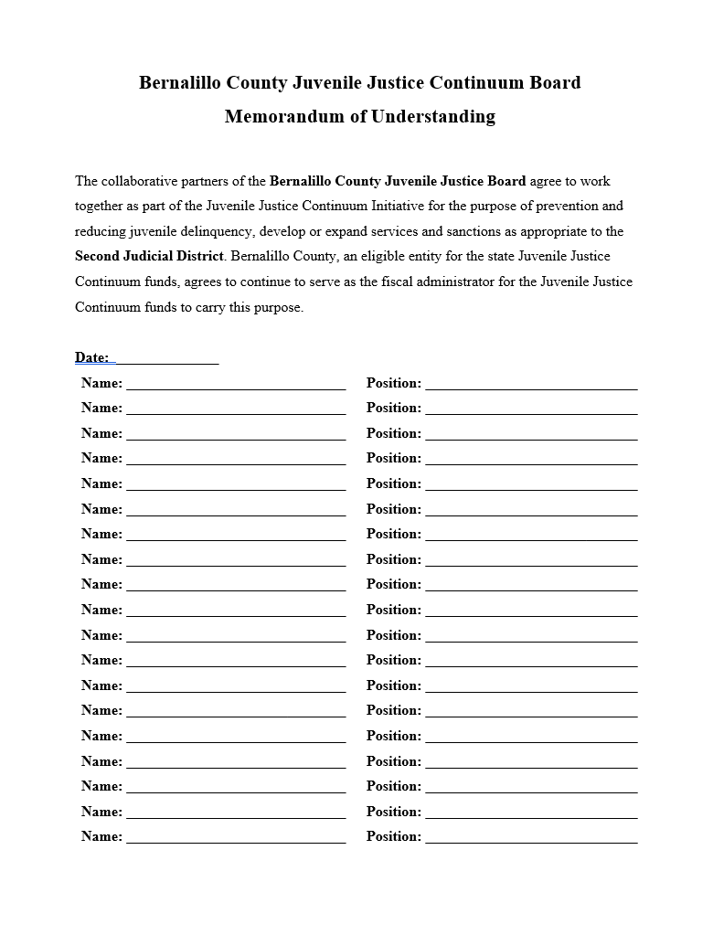

## Other Resources

[Link to New Mexico Center for Nonprofit Excellence Website](https://www.centerfornonprofitexcellence.org/?utm_source=Blast&utm_medium=Header&utm_campaign=BlastHeader)

# Program Development and Support

**Section 4:**

As referenced in the Duties and Responsibilities of Attachment 1 – Scope of Work, unless previously stated and approved in the grant application, all programs must commence and be operational within ninety (90) days of the last signatory executing the grant agreement. If the Contractor’s program has not commenced or is not operational within ninety (90) days, the Contractor must report, in writing, to the Children, Youth and Families Department (Agency) the steps taken to initiate the program, the reasons for the delay, and the expected starting date prior to the end of the ninety (90) day period. If this justification is not received prior to the ninety (90) days, the Contractor’s program, at the Agency’s discretion, may be terminated and the funds allocated to that program redistributed to other sites or programs.



## 5 Priority Programs Document

Juvenile Continuum Grant Fund Program Funding Priorities

Juvenile Justice | Field Services Special Programs/Grants Management Unit

Federal and state juvenile justice funds administered by the Grants Management Unit have five funding priority areas –

**Delinquency Prevention** – Brings a system of services and sanctions for juveniles designed to prevent or reduce referrals to the juvenile justice system. These services are aimed at increasing the number of youth served; increasing the number of programs/services available in under-served communities; improving program quality; and increasing youth accountability. Delinquency prevention services meet the needs of youth through collaboration of the many local systems before which a youth may appear, including schools, courts, law enforcement agencies, child protection agencies, mental health agencies, welfare services, health care agencies and private nonprofit agencies offering youth services.

**Alternatives to Detention** – Designed to Increase the availability and types of diversion and alternative to detention programs through a continuum of services and graduated sanctions; improve the fair and effective response to all youth who come into contact with the juvenile justice system (addressing disproportionate minority contact); and improve the juvenile justice system through continuums implementing the philosophy and approaches of the Juvenile Detention Alternatives Initiative (JDAI) and using best practice/model programs.

**Graduated & Appropriate Sanctions** – Provides youth who enter the juvenile justice system receive a developmentally-appropriate, evidenced-based risk assessment instrument to aid in the application of appropriate services and/or sanctions. This priority area ensures juvenile justice interventions are guided by each individual youth’s risk and needs; services and supports align with best practices so that youth are served in safe, developmentally-appropriate programs; and programs and practices are reviewed and adjusted to ensure they do no harm and do not cause disparities.

**Diversion/Restorative Justice** – Programs to divert youth from entering the juvenile justice system such as victim-offender mediation and restorative circles. Diversion/Restorative Justice services help ensure youth do not enter or penetrate the state's juvenile justice system unnecessarily. It is important local communities, along with the justice system, divert low-level and low-risk youth from formal involvement, thereby promoting positive youth outcomes and public safety. It is critical that Diversion/Restorative Justice strategies are provided in an equitable manner to reduce racial and ethnic disparities.

**Gender-Specific Services** – Provision of a sustainable and comprehensive system of support for addressing gender-specific needs and enhancing the strengths of young men and women in the state’s juvenile justice system with good transitional follow-up services. In recent years, male juveniles have received referrals at an average rate of twice that of female juveniles without male-specific programs to meet the needs of male clients throughout the state. Emphasis is on providing responsive, culturally sensitive services addressing the needs and behaviors of male juveniles.



## Sample Program Referral(s) Form

[Link to Program Referral Form Template](https://b58a0a99-a9ad-451b-8685-43a64b0dde0d.filesusr.com/ugd/5b2008_779f91f1bc89473fb9a5bf1b22dcf421.docx?dn=Program%20Referral.docx)

JPO or person making referral, please take a moment to **fill out/check everything** that applies to this client.

***Make 2 copies, one for client file and 1 for Master List file***

Client Name: ___________________________________________ Date of Application: _____________________ Date Referral Received: ____________________

Name of Agency for Referral Source: _________________________________ Referring Person’s Name and Phone #: __________________________________________

Client Phone #: _____________________ Cell Phone #: _____________________ School Name: ____________________________________________ Grade: ____________

Client Address: _______________________________________________________ Date of Birth: _______________ Age: _______

Parent/Guardian Name: ________________________________________ Relationship: _________________

Parent/Guardian Signature and Date: _________________________________________ Client Signature and Date: ______________________________________________

Nymber of Family Members Attending: ________________

**__________________________________________________________________________________________________________________________________________________________________**

***Please check all that apply to the individual client:***

Male: _____ Hispanic: ______ Caucasian: _____ Native American: _____ Other: ______

Female: _____ Asian: ______ African American: _____ 2 or More: _____ Declined to say: _____

Informal: _____ Formal: _____ Truancy: _____ Incorrigable: _____ Other: ______________________

At-Risk, no prior: _____ First Time: _____ Repeat: _____ Sex Offender: _____ Violent: _____ Runaway: _____

Truancy: _____ Truancy Contract: _____ Pregnant: _____ Substance Abuse: _____ Mental Health: _____

**__________________________________________________________________________________________________________________________________________________________________**

***Please check the program you are referring to:***

Boys Council: _____ Girls Circle: _____ Strengthening Families Program (Parent is required to attend): ______

***\*Your son/daughter is required to complete the above assigned hours or days for the designated program(s). They are expected to be punctual, (doors will close at the time of group), prepared to participate in the activity with a positive and respectful attitude, and must come dressed appropriately. A parent, relative or adult (18 and over)May be required to attend with the youth. No tobacco products will be allowed. Any illegal substances found will be referred to law enforcement. If clients are disruptive, appropriate dismissal procedures will be enforced. Clients may be sent home without credit and possibly banned from returning.***



## Target Population

At-risk youth, as defined above, ages 10 – 17.  If the youth enters the program at 17 years of age and turns 18 while continuing services, it is acceptable to bill until service curriculum has been completed.  Once the youth is discharged, they may not return (using our funding) if they have turned 18.

**Juvenile continuum grant fund; created; purpose; administration; grant applications.**

As used in this section, a "juvenile justice continuum" is a system of services and sanctions for juveniles arrested or referred to juvenile probation and parole or at risk of such referral …

NMAC defines it further,

**Definitions**: “At risk of such referral” means that the juvenile has demonstrated specific behaviors that if repeated will make the juvenile eligible for a referral to juvenile probation and paroles and these behaviors have come to the attention of public officials such as the public school, law enforcement or protective services officials.  Some examples are truancy and disruptive behavior in school.

FY2020 Grant Guideline document provides –

**Definitions** At-Risk Youth: The juvenile has demonstrated specific behaviors that if repeated will make the juvenile eligible for a referral to juvenile probation and parole, and these behaviors have come to the attention of public agency officials such as the public school, law enforcement or protective services officials. The referral must be from one of those public agencies specified in the Juvenile Continuum Act as a required partner in a continuum. Youth may also self-refer.

## Existing Programs

Below is a list of the Programs that are currently accessible to youth across the state.



# Contract Management

**Section 5:**

The Continuum Coordinator duties require that they manage, coordinate and oversee the management of the contracts and programmatic delivery that fall under the following Grant Funding:

Title 8, Social Services, Chapter14, Juvenile Justice, Part 13, Juvenile Continuum Grant Funds, of the New Mexico Administrative Code[8.14.13 NMAC-N, 06/29/2007] establishes the manner in which money appropriated by the New Mexico state legislature to the juvenile continuum grant fund, and other money accruing to the fund as a result of gift or deposit, shall be awarded pursuant to the Continuum Act, Laws 2007, Chapter 351.

Authorized by the federal Juvenile Justice and Delinquency Prevention Act, Title II State Formula Grants support innovative state efforts to adhere to the standards that reduce the risk of harm to court-involved youth, ensure fair treatment of minority youth, improve the way systems address delinquent behavior, and ensure citizen involvement and expertise through the State Advisory Groups/Juvenile Justice Advisory Council.



## Fiscal Agent Roles

Each county defines its own Fiscal Agent Roles. It’s important to distinguish the Continuum Coordinators Role from the Fiscal Agent Role. The Continuum Coordinator Role is provided here.

It should be noted that Continuum Coordinators who are contracting with the county / city as a fiscal agent and are paid from the continuum funding through CYFD cannot attend the Grant Proposal Meeting. Contractual Continuum Coordinators cannot work directly on the Grant Application from CYFD; they can be consulted by the fiscal agent as the fiscal agent develops the Grant Proposal.

A Fiscal Agent is defined as the Party responsible for executing the CYFD Grant Agreement including but not limited to the application, monitoring and ensuring contract compliance throughout the funded fiscal year.

For more role descriptions and information, follow the link to the [Continuum Grant Agreement](https://cyfd.org/docs/5-FY20_Continuum_Grant_Agreement_Guidance.pdf)

## Request to Subcontract

A Subcontractor is an entity that receives a sub award from a local/county/tribal government entity to carry out part of the Juvenile Continuum Grant Agreement.  The following information provides further detail on requirements on behalf of the Coordinator when a subcontract is in place:

Subcontractor definition:

a. Subcontracts should not be written as a straight draw-down of funds (lump sum payments whether one-time, monthly, or quarterly);

b. Reimbursements are monthly and must reflect actual services performed or expenses incurred. If services are being provided, reimbursements must be submitted;

c. Subcontracts should mirror the requirements in the Agreement held with the Agency and there must be no transference of liability for the Agreement. The Contractor is fully liable for all terms and deliverables of the Agreement; and

d. Contractors are responsible for the oversight of the subcontractors in terms of program compliance and outcomes. It is expected that sites will conduct periodic reviews (both fiscal and programmatic) of subcontractors for activities paid through the Agreement.

The approval to use subcontractors must be obtained prior to execution of the subcontract and services being accessible. Once the subcontract is executed, a fully executed copy must be submitted to the CYFD Grants Manager for approval of the CYFD Cabinet Secretary. Sites will not be reimbursed for services provided by subcontractors for whom approval has not been obtained and/or falls outside of the subcontract execution dates.

The request to subcontract must pass through numerous offices. Please allow for one to two weeks for a response.

[Link to Request to Subcontract Sample Letter](https://b58a0a99-a9ad-451b-8685-43a64b0dde0d.filesusr.com/ugd/5b2008_4424750195894a339667a7487511baef.pdf)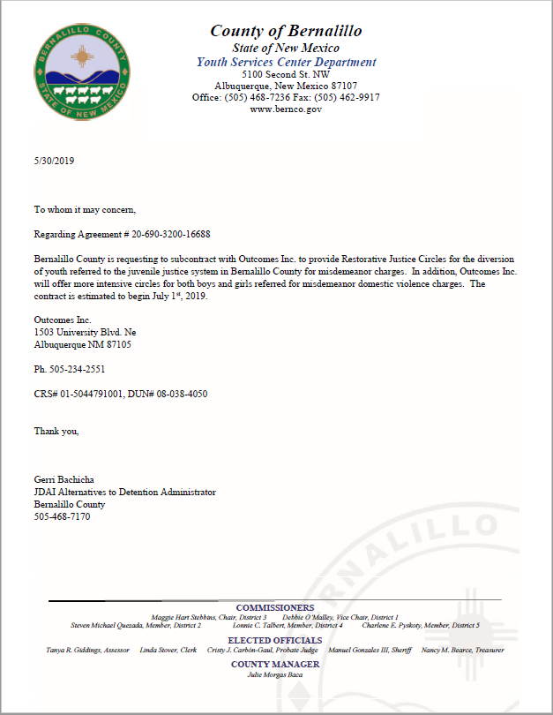

## Financial Management

Financially managing the budget in accordance with the local Continuum Board is an essential component to the continuum coordinator’s job. The continuum coordinator is responsible for sharing budgeting information to the local Continuum Board to make appropriate decisions regarding the use of the funding. A continuum coordinator’s job is the maintenance of the budget, seeking bar adjustments when necessary and providing information to CYFD at the end of the fiscal year if funds will be reverted back. The goal of the continuum coordinator is to assure that there are no funds left over and they have been spent in accordance to CYFD regulations.

### 5.3.1 Best Practice: BAR Budget Adjustment Requirement

A BAR (Budget Adjustment Request) is an instrument that allows the Contractor to request minor adjustments within the Agreement line items for services or supplies already approved by JJAC and the Cabinet Secretary (see Appendix D).  These requests are limited to the movement of funds up to 5 percent of the total grant amount.  A BAR may not change the scope or intent of the Agreement, including the addition of programs/services, travel, supplies and/or equipment.  The first BAR may not be submitted until the effected line items have had three months of expenditures.

Prior to submitting a BAR to the Grants Management Unit, it must be approved by the Continuum Board (as evidenced in the Board minutes) and by the Contractor’s authorizing agent.  The BAR and a detailed justification is then submitted to the Agency’s Grant Manager prior to any movement or alternate use of the affected funds.  The BAR form must follow the approved program names and line items of the Agreement.

The BAR will be reviewed and either approved or denied by the Grant Management Unit and/or JJAC Grant Subcommittee.  A copy of the approved or denied BAR will be returned to the Continuum Coordinator and Contractor’s authorizing agent.  The changes may take effect upon the approval date on the returned BAR form.

An approved BAR shall amend the approved budget and line item amounts.  These amended amounts shall follow all documentation from the date of approval (i.e., Expenditure Report forms, future BAR, grant review documents).

All final BAR forms must be submitted to the Agency no later than ninety (45) days (May 15th) prior to the end of the fiscal year.  Requests submitted after that day may not be accepted or approved.

### 5.3.2 FY19 REVERSION EXPLANATION

The final invoice shall encompass all remaining expenses incurred and paid through June 30th.  Once the final invoice is processed, the grant is closed.  Expenses incurred within the terms of the Agreement will not be reimbursed on the following fiscal year invoices. The final invoice shall not reflect an attempt to draw down all remaining funds budgeted in the Agreement.  Expenditures that cannot be validated with the required supporting documentation will not be reimbursed. Upon the completion of the final invoice any funds left over will be reported to CYFD in a JJAC Reversion Explanation form. The Explanation will detail each program or expense area that will be reverted and must be returned by July 15 along with the annual report.



## Annual Report Requirements

The Contractor will submit to the Agency a written Final Report prior to the termination of the grant and such other reports deemed necessary by the Agency.  The Final Report is to contain, at minimum, but not restricted to:

1. a year plan for sustainability of programs/services; and

2. accomplishments/milestones achieved during the grant period; and

3. statements regarding achievement, obstacles and progress made regarding performance measures and related outcomes; and

4. continuing development and improvement of the Comprehensive Strategic Plan for a continuum of detention alternative programs and services.

[Link to Sample Annual Report](https://b58a0a99-a9ad-451b-8685-43a64b0dde0d.filesusr.com/ugd/5b2008_bbec9ca4a49e405da847329f617b3ddf.pdf) – Los Alamos2018

## Information on Background Checks

According to Article XXI. Background Checks, any Contractor or subcontractor, that may have primary custody of children for at least twenty hours per week, are required to comply with NMAC 8.8.3 et. seq. requiring background checks on any employee, staff, volunteer or student intern, that has direct care responsibilities or potential unsupervised physical access to clients.

As advised by the Agency’s Office of General Counsel, when determining who shall have a background check, please adhere to the following questions:

1.       Does the program have children participating in the program at least 20 hours per week? If no, then no background check.  If yes, proceed to question number 2.

2.       Does the staff member in question have direct care responsibilities or potential unsupervised physical access to children?  If yes, the staff member needs a background check from CYFD pursuant to the contract and our regulations.   If no (for example a budget person that does interact with clients), then no background check is needed.

Once it is determined that a background check is required, please have the fiscal agent contact the CYFD Background Check Unit, please use the following means:  [CYFD.BCU@state.nm.us](mailto:CYFD.BCU@state.nm.us) or (505) 827-7326 for requirements and cost.

The CYFD Background Check Unit’s Letter of Eligibility must be in the person’s employee file prior to any contact with the youth.

 The CYFD eligibility letter, for any position funded by this Agreement, must be submitted to the Agency within fifteen (15) days of receipt. Eligibility is valid until there is an employee break in service

## RFP / Grant Agreement Guidance

The Grant Agreement Guidance is an essential document that you should refer to when executing your contract with CYFD.

[FY 20 Continuum Grant Agreement Guidance](https://cyfd.org/jjs-special-programs/grant-management-unit/juvenile-continuum-grant-funds)

[FY 19 Continuum Grant Agreement Guidance](https://cyfd.org/docs/24-_FY19_Continuum_Grant_Agreement_Guidance.pdf)

## Match

Local matching funds may consist of money, land, equipment or in-kind services. “Match” is the portion of program costs that IS NOT paid for the program by grant funds as part of the fee for service. “In-kind” contributions represent the value of non-cash contributions provided that is used to achieve program objectives. This non-cash contribution is from third parties, such as public agencies, private organizations, sponsors, and individuals. “Cash” contributions are donated by a third party and is expended to fund allowable program costs.

For every dollar of Continuum funds requested from the Agency, the Contractor must provide forty cents ($.40) in match contribution.  Match may take the form of cash or the valuation of non-cash contributions (in-kind).  In-kind may be in the form of services, materials, or equipment given without charge to the Contractor.  Match must be used to support the Agency funded projects.  Match must be determined on standard objective sources and must be verifiable.  Match contributions may only be claimed in the same month as utilized (i.e., cannot consider a year’s lease in one lump sum; it must be credited monthly).

When reporting match contributions, a separate, additional Expenditure Report from must be completed and marked accordingly in the upper right corner (see Appendix C).  Contractors may elect to report match contributions within the same contract line items as approved, or elect to itemize the match contributions by type.  One lump sum total titled match will no longer be accepted.

The Match Expenditure Report form and supporting documentation shall be the last section of the invoice package.

Acceptable forms of match and documentation are:

**A.    Volunteer Services**

Unpaid services provided to a Contractor, by individuals, will be valued at rates set by the Agency.  Volunteer service is an important component to many programs.  The rates below have been determined as reasonable and verifiable for certain activities within the State of New Mexico.  When determining your volunteer in-kind, supporting documentation should be sign-in sheets, the hours worked, activity performed, and the calculation for value of hours.

The rates are:

1.     Community Service Project Volunteer                          $11.20

2.     Volunteer providing skilled office/labor work              $19.77

3.     Board Member attending a Board Meeting                 $22.55

4.     Professional Service Volunteer                        Professional Rate

(Physician, architect, plumber, etc. providing those specific services)

**B.     Building Usage**

When using the value of a building and/or office space as match contribution, the value must be verifiable.  Unless the whole building/office space is used for the funded programs, the value shall be calculated on the square footage actually utilized by the funded programs.  For a building usage to be used as a match, the space used must be available for the public to use. For example, a community room is allowable, but an office in a school is not allowable.

The following are acceptable sources of documentation:

1.     Rental agreement with proof of payment; or

2.     Mortgage agreement with proof of payment.

For areas donated by an entity different than the Contractor/subcontractor or no rent or mortgage is paid, a valuation, by a real estate professional or facilities manager, detailing total square footage, present value based on comparable costs, and total monthly value.

**C.    Receipts**

Documentation must include the itemized receipt showing the entity purchased from, the date of purchase and the method of payment.  Receipts shall not include unallowable items.  Unallowable items, such as personal purchases, food, alcohol, etc., should not be comingled on a receipt.  These items should be purchased separately.

**D.    Other Forms of Match**

When submitting other forms of match, be sure to follow the same guidelines as if the expense would be submitted for reimbursement.

Contractors and subcontractors are encouraged to continue reporting match contribution, once the mandatory 40 percent is met.  This continued reporting will assist in calculating the true cost of the program.  Continuums may elect to stop reporting match when the 40 percent is met and include the actual match contributions on the Final Annual Report.

## Audit Information

As referenced in Article VIII. Maintenance of Records of the current grant Agreement, the Contractor must retain detailed records during the Agreement’s term and retain them for a period of three (3) years from the date of the final payment under the Agreement.  The records are subject to inspection by the Agency, Department of Finance and Administration and the State Auditor.

The Agency shall have the right to audit billings both before and after payment.  Payment under this Agreement shall not foreclose the right of the Agency to recover excessive or illegal payments.  The Contract agrees to comply with the requirements and regulations set forth in Attachment 3 – Administrative and Fiscal Standards, unless the Contractor effectively demonstrates in writing, with written approval from the Agency, that any specific standard is inapplicable to such Contractor.

# FAQ’s

# Glossary

BAR: Budget Adjust Request

CAB: Community Advisory Board

CJJ: Coalition for Juvenile Justice

CWC- Community Wellness Council

CYFD- Children Youth and Family Department

DWI- DWI Council

ERE- Equitable Results Engagement

FY: Fiscal Year

JCC: Juvenile Community Corrections

JDAI- Juvenile Detention Alternative Initiative

JJAC- Juvenile Justice Advisory Committee

JJB- Juvenile Justice Board

JPO- Juvenile Probation Officer

MOU: Memorandum of Understanding

OSAP- Office of Substance Abuse Prevention

PD- Police Department

RAC- Reception Assessment Center

RJ- Restorative Justice

# **Disclaimer**

# This manual was developed by the Continuum Coordinators Coalition in Conjunction with the CYFD Special Projects unit.  This manual is not meant to serve as the authority on all Continuum Coordinator duties, Fiscal Agent responsibilities or grant requirements.

**This manual is meant to help new coordinators orient themselves to the work as quickly as possible.**

If you find any information contained within this manual that is contradictory or slightly different from other information you have received, please clarify the information with the CYFD Special Programs unit staff.

# CYFD Special Programs Contact Information

|  |  |  |  |
| --- | --- | --- | --- |
| **Name** | **Title** | **Email** | **Phone** |
| William Kearney | Special Programs Manager / JJ Specialist | William.Kearney@state.nm.us | 505-469-5325 |
|  |  |  |  |
| Cindy Varela | Grants Management, Unit Manager | [cindy.varela@state.nm.us](mailto:cindy.varela@state.nm.us) | 505-629-3223 |
|  |  |  |  |
| Vacant |  |  | 505-709-8453 |
|  |  |  |  |
| Louis Pacias | Grants Manager | [louis.pacias@state.nm.us](mailto:louis.pacias@state.nm.us) | 505-660-3405 |
|  |  |  |  |
| Consuelo Garcia | Grants Manager | [Consuelo.garcia1@state.nm.us](mailto:Consuelo.garcia1@state.nm.us) | 505-470-7494 |
|  |  |  |  |
| Patti Vowell | System Improvement Coordinator | [Patti.vowell@state.nm.us](mailto:Patti.vowell@state.nm.us) | 505-231-3489 |
|  |  |  |  |
| Steven Brooks | Racial and Ethnic Disparities Coordinator | [Steven.brooks@state.nm.us](mailto:Steven.brooks@state.nm.us) | 505-670-5708 |
|  |  |  |  |
| Samantha Lucas | Detention Compliance Monitor | [Samantha.lucas@state.nm.us](mailto:Samantha.lucas@state.nm.us) | 505-490-1067 |
|  |  |  |  |
| Amanda Gray | Operations Research Analyst | [Amanda.gray@state.nm.us](mailto:Amanda.gray@state.nm.us) | 505-470-7121 |
|  |  |  |  |
| Kim Robinson | Executive Secretary | [Kim.robinson@state.nm.us](mailto:Kim.robinson@state.nm.us) | 505-309-2905 |
|  |  |  |  |

# Continuum Board Leader Contact Information

|  |  |  |  |
| --- | --- | --- | --- |
| **Continuum Site** | **Name** | **Title** | **Email** |
| City of Artesia (Eddy County) | Brissa Padilla | Coordinator | briclc@pvtn.net |
|  |  |  |  |
| Bernalillo County | Carmela Romero | Coordinator | cromero@bernco.gov |
|  |  |  |  |
| Chaves County | Lucia Serrano | Coordinator | [lserrano@co.chaves.nm.us](mailto:lserrano@co.chaves.nm.us) |
|  |  |  |  |
| Grant County | Bianca Padilla | Coordinator | bpadilla@silvercitynm.gov |
|  |  |  |  |
| City of Las Cruces (Dona Anna County) | Javier Amaro | Coordinator | [jamaro@las-cruces.org](mailto:jamaro@las-cruces.org) |
|  |  |  |  |
| Lincoln County | TBD | Coordinator | - |
|  |  |  |  |
| Los Alamos County | Lisa Zuhn | Coordinator | [lisaz@losalamosjjab.com](mailto:lisaz@losalamosjjab.com) |
|  |  |  |  |
| Luna/Hidalgo Counties | Desa Malina | Coordinator | desa_malina@lunacountynm.us |
|  |  |  |  |
| Otero County | TBD | Coordinator | [-](mailto:aotero@tcc-nm.org) |
|  |  |  |  |
| City of Raton (Colfax County) | Danielle Vanderpool | Coordinator | advocate@youthheartline.org |
|  |  |  |  |
| Rio Arriba County | Nora Lovato | Coordinator | [nglovato@rio-arriba.org](mailto:nglovato@rio-arriba.org) |
|  |  |  |  |
| San Miguel County | TBD | Coordinator | - |
|  |  |  |  |
| Sandoval County | Judith (Judy) Lovato | Coordinator | jmlovato@sandovalcountynm.gov |
|  |  |  |  |
| City of Santa Fe | Julie Sanchez | Coordinator | jjsanchez@santafenm.gov |
|  |  |  |  |
| City of Socorro (Socorro County) | Kirstin Keller | Coordinator | [kirstin.keller@hotmail.com](mailto:kirstin.keller@hotmail.com) |
|  |  |  |  |
| City of T or C (Sierra County) | Jaylah Pendelton | Coordinator | dowj1@wnmu.edu |
|  |  |  |  |
| Town of Taos (Taos County) | TBD | Coordinator | - |
|  |  |  |  |
| Torrance County | Rebecca Armstrong | Coordinator | armstrongrebecca73@gmail.com |
|  |  |  |  |
| Valencia County | Cassandra (Casey) Montano | Coordinator | cassmontano@gmail.com |

*Note: CYFD Special Project Staff is the ultimate authority to be contacted in the event that there is a question that cannot be answered by another by a Coordinator Lead or another Coordinator.